Assignment No. 08

Roll No. SC55 - Shreyas Chavhan

===================================================

# File Handling

## Problem Statement -

Write a menu driven program that will create a data file containing the list of

telephone numbers in the following form

John 23456

Ahmed 9876

........................

Use a class object to store each set of data, access the file created and implement

the following tasks

I. Determine the telephone number of specified person

II. Determine the name if telephone number is known

III. Update the telephone number, whenever there is a change.

## Theory -

Stream:

A stream is a sequence of bytes. It acts as source from which the input data can be

obtained or as a destination to which the output data can be sent.

1. Input Stream

Input Streams are used to hold input from a data producer, such as a keyboard, a

file, or a network. The source stream that provides data to the program is called

the input stream. A program extracts the bytes from the input stream. In most

cases the standard input device is the keyboard. With the cin and “extraction”

operator ( &gt;&gt;) it is possible to read input from the keyboard.

2. Output Stream

Output Streams are used to hold output for a particular data consumer, such as a

monitor, a file, or a printer. The destination stream that receives data from the

program is called the output stream. A program inserts the bytes into an output

stream. By default, the standard output of a program points at the screen. So

with the cout operator and the “insertion” operator (&lt;&lt;) you can print a message

onto the screen.

iostream standard library provides cin and cout methods for reading from standard

input and writing to standard output respectively.

file handling provides three new data types:

Data Type Description

ofstream -

This data type represents the output file stream and is used to

create files and to write information to files.

ifstream -

This data type represents the input file stream and is used to read

information from files.

fstream -

This data type represents the file stream generally, and has the

capabilities of both ofstream and ifstream which means it can

create files, write information to files, and read information from

files.

## Code -

|  |
| --- |
| /****************************************************************  Assignment No. 8 -  Write a menu driven program that will create a data file containing the list of  telephone numbers in the following form  John 23456  Ahmed 9876  ........................  Use a class object to store each set of data, access the file created and implement  the follwoing tasks  I. Determine the telephone number of specified person  II. Determine the name if telephone number is known  III. Update the telephone number, whenever there is a change.  ****************************************************************/  #include <iostream>  #include <fstream>  #include <string.h>  using namespace std;  class PhoneBook{  public:  long int telephone;  string name;  void input(){  cout << "<Name> <telephone>" << endl;  cin >> name >> telephone;  }  void output(){  cout << name << " " << telephone << endl;  }  };  int main(){  PhoneBook record;  long int telephone_number, choice, pos, offset, i;  string name;  fstream fp;  ifstream in;  ofstream out;  while(true){  cout << endl;  cout << "1. Read a file" << endl;  cout << "2. Write into a file" << endl;  cout << "3. Determine Name if telephone number is specified" << endl;  cout << "4. Determine telephone if name is specified" << endl;  cout << "5. Update telephone number" << endl;  cout << "6. Exit" << endl;  cout << "Enter your choice: ";  cin >> choice;  switch (choice){  case 1:  in.open("PhoneBook.txt", ios::in | ios::binary);  cout << "The contents of file are: " << endl;  while(in.read((char*)&record, sizeof(record))){  record.output();  }  in.close();  break;  case 2:  record.input();  char ch;  cin.get(ch);  out.open("PhoneBook.txt", ios::out | ios::app | ios::binary);  out.write((char*)&record, sizeof(record));  out.close();  break;  case 3:  cout << "Enter the phone number: ";  cin >> telephone_number;  fp.open("PhoneBook.txt", ios::ate | ios::in | ios::out | ios::binary);  fp.seekg(0, ios::beg);  pos = -1;  i = 0;  while(fp.read((char*)&record, sizeof(record))){  if(telephone_number == record.telephone){  pos = i;  break;  }  i++;  }  offset = pos * sizeof(record);  fp.seekp(offset);  fp.read((char*)&record, sizeof(record));  cout << "Name: " << record.name << endl;  fp.close();  break;  case 4:  cout << "Enter the name: ";  cin >> name;  fp.open("PhoneBook.txt", ios::ate | ios::in | ios::out | ios::binary);  fp.seekg(0, ios::beg);  pos = -1;  i = 0;  while(fp.read((char*)&record, sizeof(record))){  if(!name.compare(record.name)){  pos = i;  break;  }  i++;  }  offset = pos * sizeof(record);  fp.seekp(offset);  fp.read((char*)&record, sizeof(record));  cout << "Telephone Number: " << record.telephone << endl;  fp.close();  break;  case 5:  cout << "Enter the name: ";  cin >> name;  fp.open("PhoneBook.txt", ios::ate | ios::in | ios::out | ios::binary);  fp.seekg(0, ios::beg);  pos = -1;  i = 0;  while(fp.read((char*)&record, sizeof(record))){  if(!name.compare(record.name)){  pos = i;  break;  }  i++;  }  offset = pos * sizeof(record);  fp.seekp(offset);  cout << "Current telephone number: " << record.telephone << endl;  cout << "Enter new telephone number: ";  cin >> telephone_number;  record.telephone = telephone_number;  fp.write((char*)&record, sizeof(record)) << flush;  cout << "Record Updated." << endl;  fp.seekg(0);  while(fp.read((char*)&record, sizeof(record))){  record.output();  }  fp.close();  break;  case 6:  return 0;  default:  cout << "Invalid Choice" << endl;  }  }  } |

Roll No. SC55 - Shreyas Chavhan

===================================================

## Output -

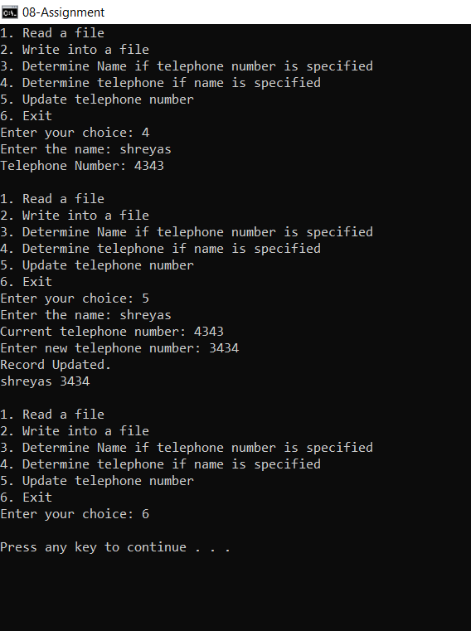

===================================================

Roll No. SC55 - Shreyas Chavhan